Project report

**TRACING THE GROWTH OF GLOBAL COMMUNITY:A POPULATION FORECASTING ANALYSIS**

INTRODUCTION

* 1. Overview

The world's population is more than three times larger than it was in the mid-twentieth century. This dramatic growth has been driven largely by increasing numbers of people surviving to reproductive age, the gradual increase in human lifespan, increasing urbanization, and accelerating migration. Major changes in fertility rate have accompanied this growth. These trends will have far-reaching implications for generations to come.

* 1. Purpose

Population projection is important since it helps people i.e government, researchers, make decisions about the future. Here are some possible ways that people use the result of population projection. 1. Estimate the basic need for human, such as demand for food, water, power, transportations

PROBLEM DEFINITION AND DESIGN THINKING

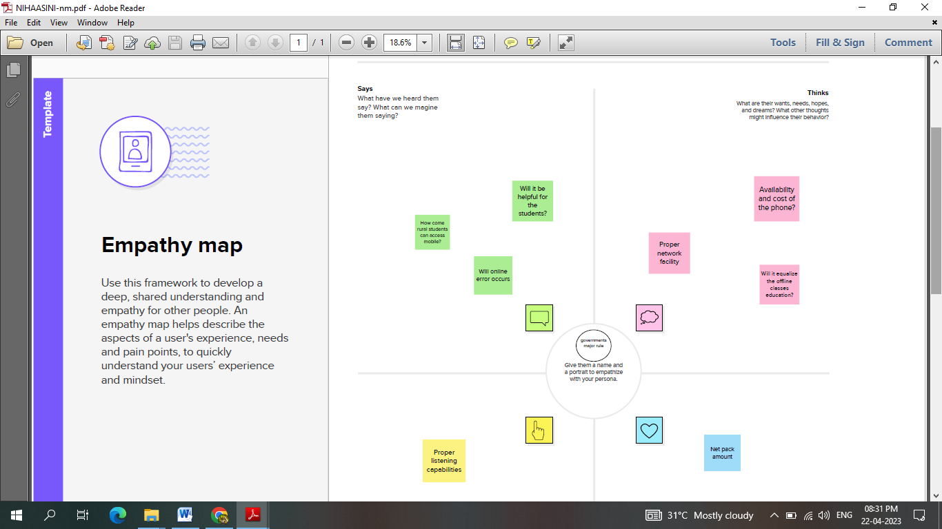2.1 EMPATHY MAP

2.2 IDEATION & BRAINSTORMING MAP  
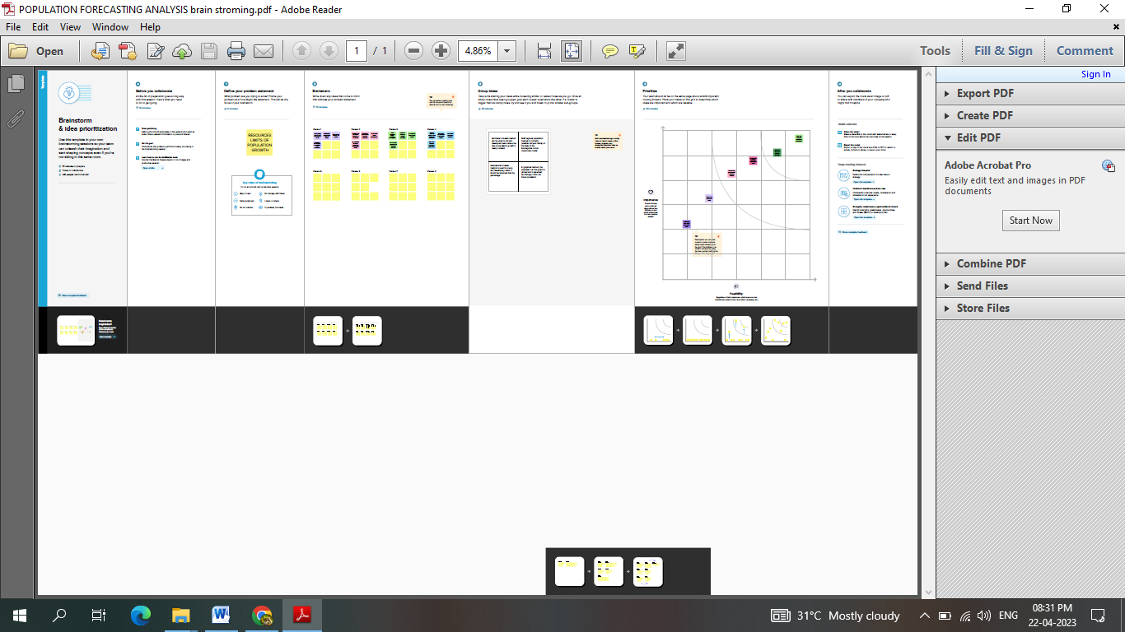

RESULT

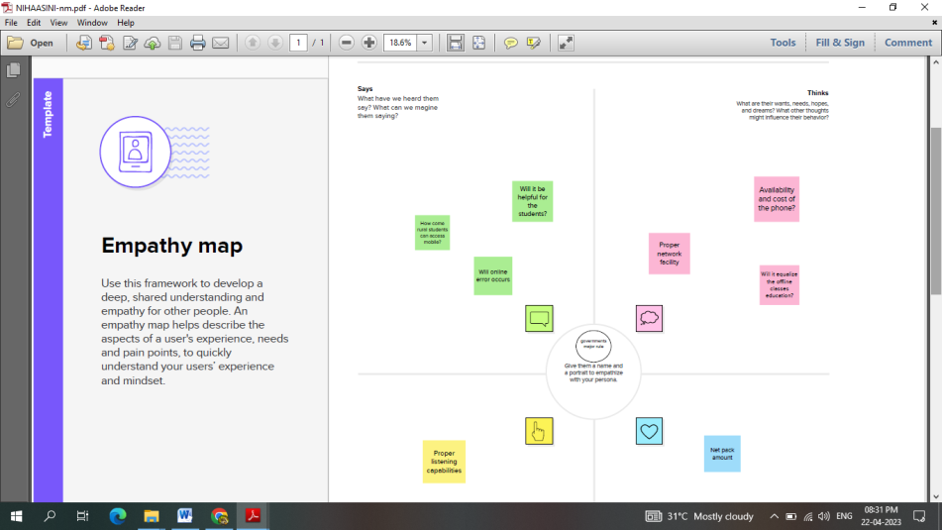

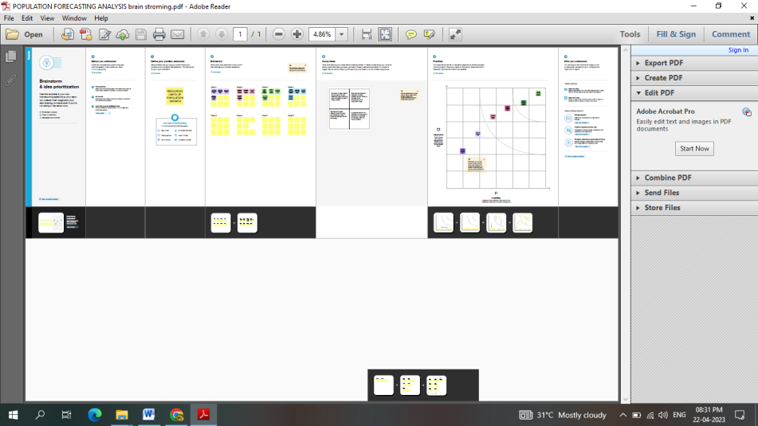

4 ADVANTAGES & DISADVANTAGES

**ADVANTAGES**

1. Estimate the basic need for human, such as demand for food, water, power, transportations.

2. Plan constructions such as housing, highways etc.

3. Estimate the labor forces in various places.

4. Estimate the potential consumptions in various regions.

5. Benefit sociological research, such as providing data about sex ratio or age ratio.

**DISADVANTAGES**

* Trying to reduce carbon and methane emissions to reduce global warming is relatively more difficult as the population.
* There will be greater threat on natural habitats as a greater population has greater demand for housing and farmland. This will increase pressure to cut down forests to make way for farming and housing.
* Higher population will lead to a greater consumption of non-renewable resources, leading to a faster depletion of natural resources.

**5. APPLICATIONS**

* All projections are used in producing household projections
* National population projections (NPP) are a key input to the Office for Budget Responsibility long-term fiscal projections published in the fiscal sustainability report
* NPP are used to produce forecasts of expenditure for benefits and pensions and as a key input for analysis on policy areas such as extending working lives
* NPP are used as the basis for Department for Education projections of future school pupil numbers

6.CONCLUSION

Forecasting helps to set goals and plan ahead.Having accurate data and statistics to analyse helps businesses to decide what amount of change, growth or improvement will be determined as a success. By having these goals, companies can better evaluate progress.

**7.FUTURE SCOPE**

A population projection gives a picture of what the future size and structure of the population by sex and age might look like. It is based on knowledge of the past trends, and, for the future, on assumptions made for three components: fertility, mortality and migration

8.Appendix

Source code

<https://github.com/Nihaasini/Tracing-the-growth-of-global-community-a-population-forecasting-analysis>

<https://drive.google.com/file/d/1IYVor-oroaPm_97kVqOTFtWyev2C4jIZ/view?usp=drivesdk>